**Choosing the model to be a Decision tree regressor:**

from sklearn.ensemble import RandomForestRegressor

Rf = RandomForestRegressor(n_estimators = 10, random_state = 10)

Rf = make_pipeline(columns_trans, Rf)

Rf.fit(X_train, Y_train)

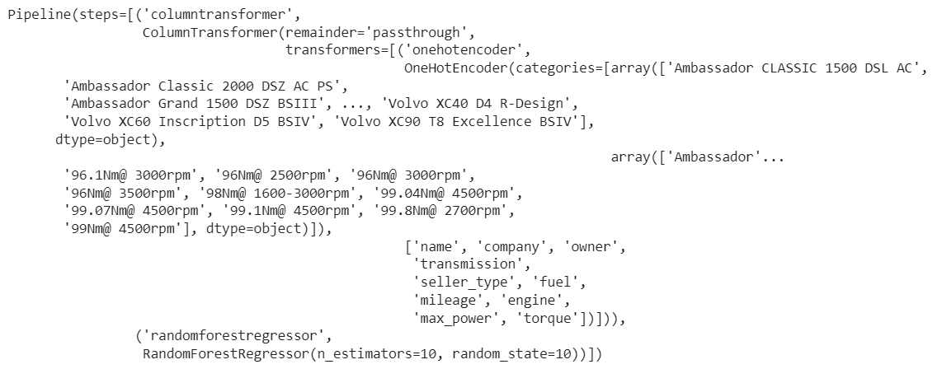

Rf_train_pred = Rf.predict(X_train)

Rf_test_pred = Rf.predict(X_test)

# R Square

r2_score = metrics.r2_score(Y_train, Rf_train_pred)

print(f"Training: R Square: {r2_score}")

# Cross Validation

cross_val = cross_val_score(Rf ,X_train ,Y_train ,cv=5)

print(f"Training: Cross Validation: {cross_val}")

# R Square

r2_score = metrics.r2_score(Y_test, Rf_test_pred)

print(f"Testing: R Square: {r2_score}")

# Cross Validation

cross_val = cross_val_score(Rf ,X_test ,Y_test, cv=5)

print(f"Testing: Cross Validation: {cross_val}")

